Practical - 6
Practical Title: Rendering External JSON Data using Fetch API, Search
and Filter

Problem Definition: Display event lists, student profiles, notices, or FAQs from external JSON files
using Fetch API. Implement dynamic rendering, search, filter, sorting, and pagination.

Theory :

1. How is JSON fetched, parsed, and rendered?
JSON is fetched using the Fetch API, parsed using response.json(), and then rendered dynamically on
the webpage using JavaScript DOM methods such as textContent or innerHTML.

2. Which array methods are used for search, filter, sort, and pagination?
filter() is used for search and filtering, sort() for sorting, and slice() for pagination.

3. How are loading and error states handled?
Loading is handled using the Fetch API, while errors are handled using the .catch() method and
displayed in the browser console.

4. How is modularity maintained in JavaScript files?
Modularity is maintained by using an external JavaScript file and separating different functionalities
into independent code sections or functions.
- Evidence of Work (Screenshots):

Students Data:
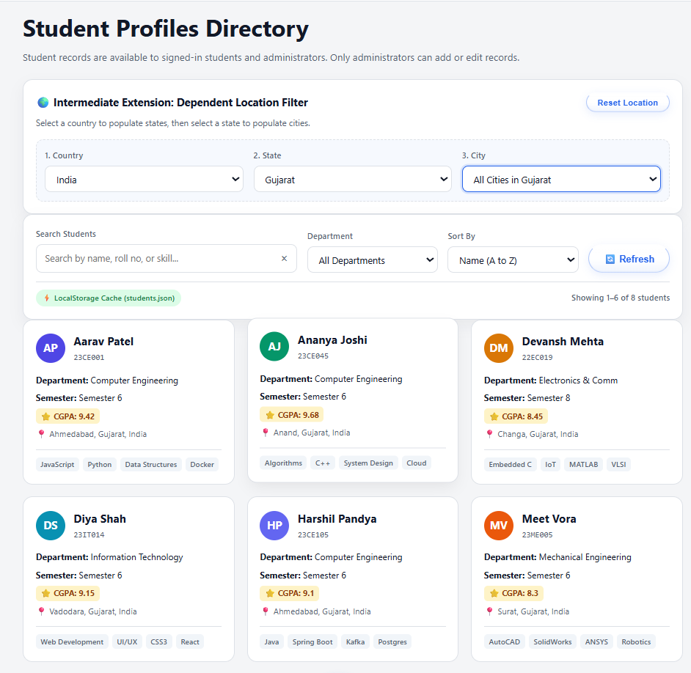

FAQs:-
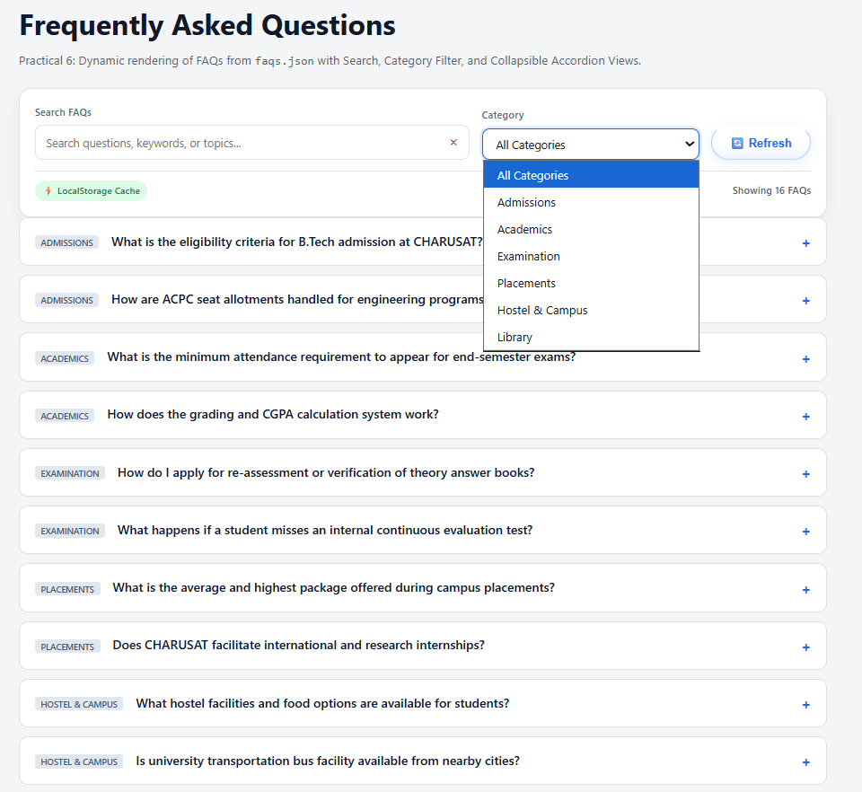

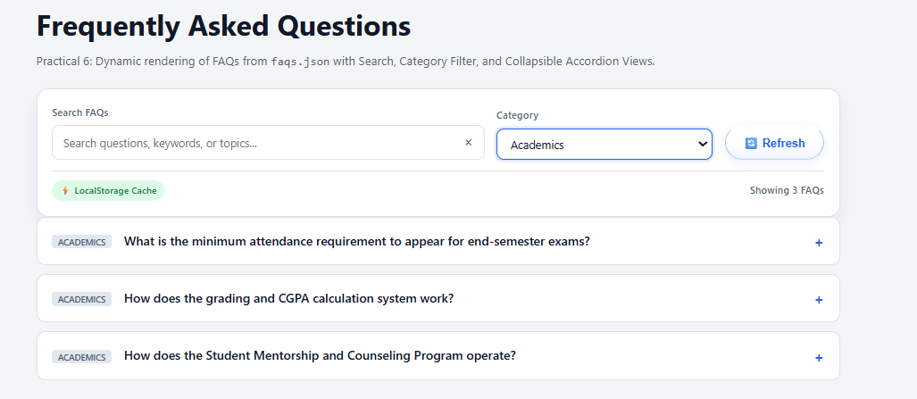

Event Data:- 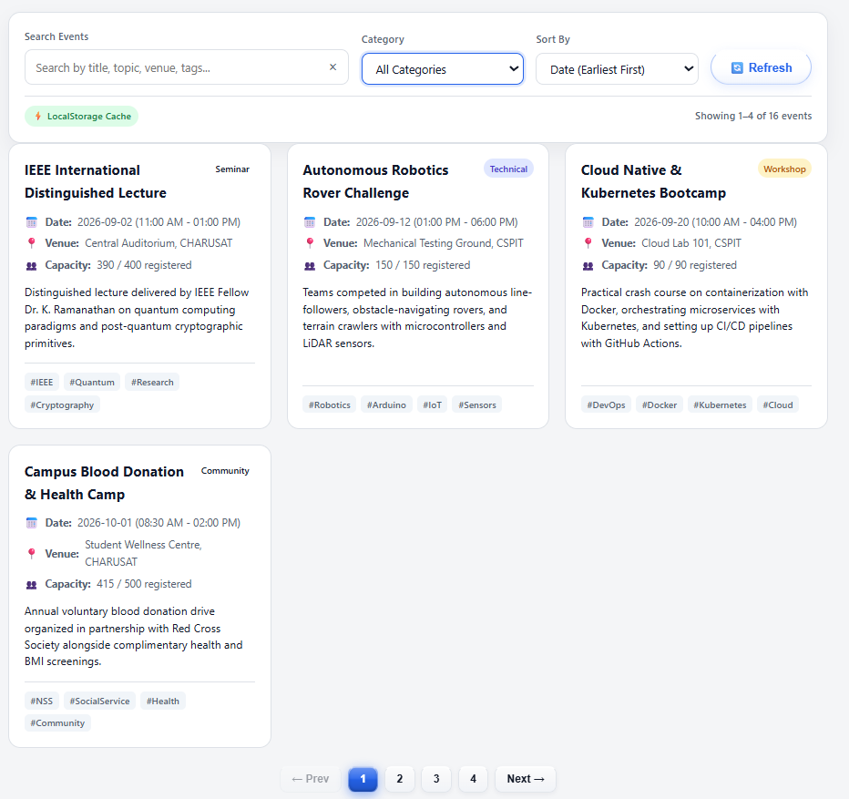

Repository Link :-
https://github.com/meet-3834/Student-Hub/tree/main/FINAL%20Submission

- Learning Outcomes:
I am able consume external JSON data and render reusable frontend
views.

Faculty Remarks: (Keep this blank for faculty)

